SASKATCHEWAN RIVERS, FERRIES, AND FORKS
August 2 – September 18, 2020
LeeAnne Clarke, John Clarke, and Brian Unverricht

Introduction
The three of us have travelled together over many years, often to Europe. After our April trip to Portugal was cancelled due to the Covid-19 pandemic, we decided to stay close to home and ride all 12 ferries located on the South and North Saskatchewan rivers. Our base was Saskatoon, and we planned numerous other activities to accompany these ferry adventures. We completed one to four ferries each day and included two overnights. Ferry crossing times varied between 2 and 24.5 minutes. Sometimes we were the only car, often there were more, and the maximum number of vehicles crossing with us was two cars beside two semis. Each of us created a one-sentence reflective statement of our impression of the crossing.
We learned fascinating historical, geographical, and cultural facts about our province by visiting with the ferry operators and local residents. Highlights included art galleries, churches, wild animals (including a bear leaping in a wheat field), historical sites, local food, golf courses, terrific panoramas, and other prairie icons.

Our motto – Covid be damned, safety commands, Travel Saskatchewan!

Timeline
Number | Dates | Ferries
1 | August 2 | Wingard
2 - 3 | August 4 | Hague and Clarkboro
4 - 7 | August 20 | St. Laurent, Fenton, Weldon, and Cecil
8 | August 26 | Riverhurst
9 | September 1 | Paynton
10 - 11 | September 17 | Lancer and Lemsford
12 | September 18 | Estuary

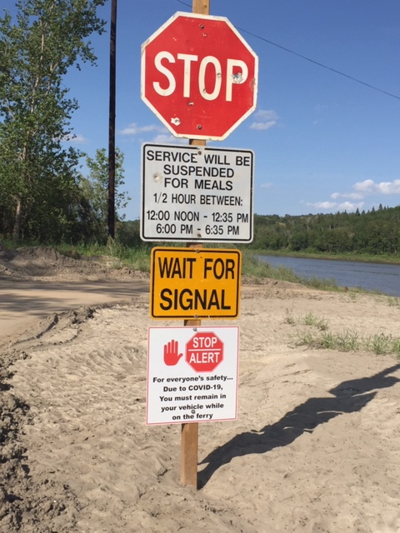
Every crossing had a stop sign, where vehicles wait for
the ferry operator. When ready, we were waved aboard.
1. August 2 – Wingard Ferry, North Sask. River
Type: cable/angle, capacity 6 cars. Crossing time = 4 minutes
First crossing: 1895 to present
Daily crossings: 70 – 130, today about 70 @ 4:57 pm
Current: 400 cubic meters/second
At shutdown it was 2000 cubic meters/second
John – “The long and dusty road led to a short and sweet ferry ride.”
LeeAnne – “For 36 years the operator has worked on the only ferry left between the Battlefords and Prince Albert on the North Saskatchewan River.”
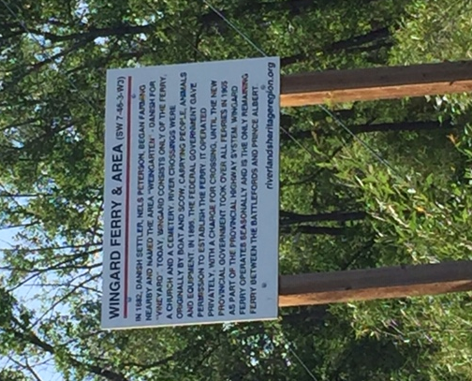
2. August 4 – Hague Ferry, South Sask. River
Type: cable, capacity 6 cars. Crossing time = 3 minutes
Daily crossings: about 18, up to about 10,000 per year. Earliest crossing date was April 29, 2020, until late December
Current: 240 cubic meters/second
The operator spoke about the cable breaking this year. Some younger kids and an older man were travelling on the ferry. He used plywood to steer the ferry back to shore.
John – “The ferryman was born in the field on the south side of the river.”
Brian – “They steer the ferry with a piece of plywood if the motor quits or the cable breaks, which did happen this year.”
LeeAnne – “The Hague ferry is the peaceful connector between huge dairy farms and the vast grain farms on the South Sask. River.”
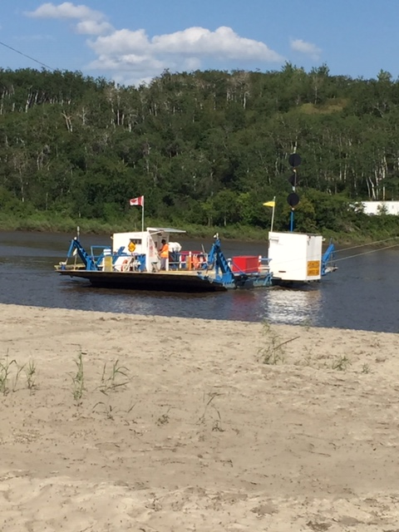
3. August 4 – Clarkboro Ferry, South Sask. River
Type: cable, capacity 6 cars. Crossing time = 2 .5 minutes
Daily crossings: about 200/day during 2020. This is the busiest ferry in the province with 70,000 crossings during 2019. The first memorable crossing was 1885, with the Louis Riel rebellion just up stream. This ferry was built in 1968.
Brian – “Crossing Clarkboro ferry with two Clarkes, two cars, and a half-ton truck; and waiting on the other side were two half-ton trucvks, raising the question of how many vehicles crossed between 3:03 and 3:09’30.”
John – “The reticent ferryman ran out to tell us that there had been a ferry upriver during the Riel rebellion.”
LeeAnne – “At 3:05pm on August 4th, 2020 this ferry already had 200 vehicles use the Clarkboro crossing.”

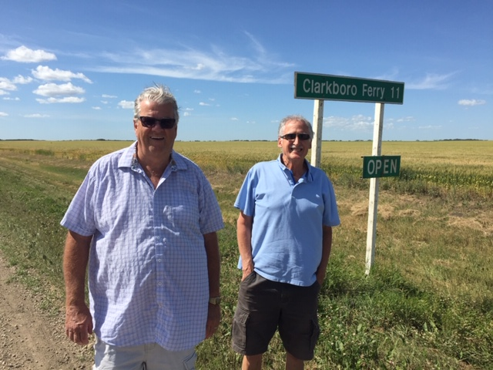

4. August 20, 2020 – St. Laurent Ferry, South Sask. River
Type: cable, one button control. Crossing time = 5’13”
Daily crossings: today about 23 so far, up to 700 per week. The water weeds were bad today. Our operator told a story about the “walkers that cross the river on the ferry”
History: in 1883 Brother Piquet founded the St. Laurent Grotto, whose waters have healing properties. This Grotto is a pilgrimage site, a very peaceful and beautiful space with a large outdoor church (Our Lady of Lourdes)
John – “ The St. Laurent crossing was a magical and spiritual crossing.”
Brian – “We had a fun chat with our operator.”
LeeAnne – “The button throttle ferry took us slowly (5’13”) across the South Sask. River from the sand dune banks to the open prairie farmland.”

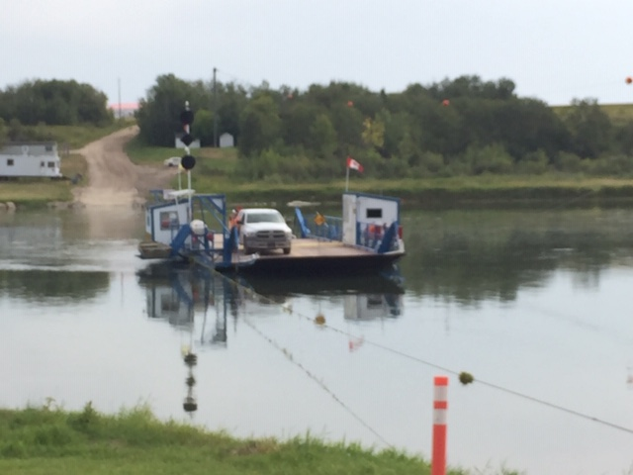

5. August 20, 2020 – Fenton Ferry, South Sask. River
Type: cable. Crossing time = 2’54”. The water level was down – operators used painted stones on the shore to mark the water level of the river. Located near the train bridge, which has stories about at “ghost light” that many have seen
Daily crossings: today, 5 cars so far
Story: The ferry was shut down yesterday because of weeds and low level of the water.
John – “The ferrywoman chatted about her family.”
Brian – “ Painted rocks about six feet apart on the side of the road showed the level of the river.”
LeeAnne – “Weeds, sand bars and low water levels bring grief to our first lady ferry operator.”

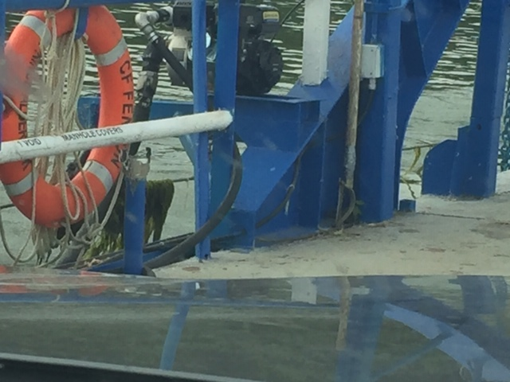

6. August 20, 2020 – Weldon Ferry, South Sask. River
Type: we noted the manual counter on the wall – hand driven throttle. Crossing time = 2’13”
Daily crossings: 15 cars so far today, at 12:31 pm
History: this ferry has been used to deliver grain as far back as 1895
Story: operator saw lots of wild life this year such as bear cubs (twins and triplets)
John – “After a short ferry ride, we saw a black bear leaping through the wheat fields.”
Brian – “The somewhat reluctant female operator had little to say, but described
the abundant wildlife.”
LeeAnne – “This is the first time we had company on a ferry – four other vehicles.”

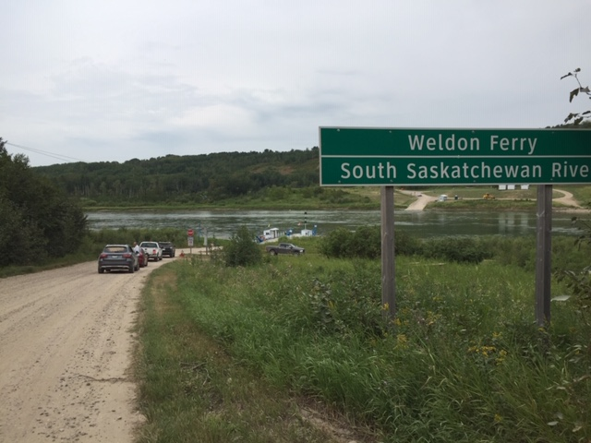

After the Weldon ferry (side trip)
We stopped for a picnic lunch overlooking the convergence of the North and South Sask. Rivers. It was a spectacular view of amazing cliffs – very quiet and peaceful. After lunch we hiked down to The Forks. It was a really steep grade and the sun was really, really hot. Later we tried to find the old power dam at LaColle Falls, but never finished.

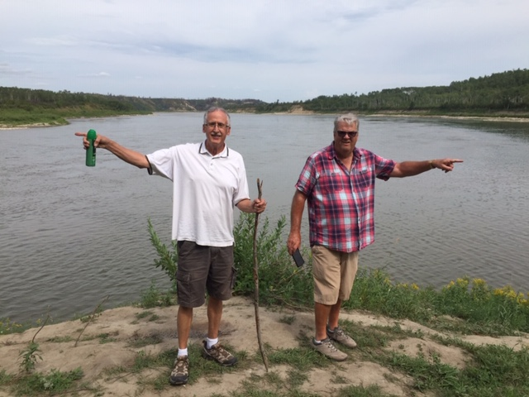
The Forks – convergence of the North and South Sask. rivers
Brian points to the north river, John to the south

7. August 20, 2020 – Cecil Ferry, North Sask. River
Type: Time of crossing = 2’21”. Speed of the river is 470 cubic meters/second
Daily crossings: about 65 today since 8:00 am
Story: It’s mostly trucks crossing here, along with farm machinery – tractors and swathers. There’s an island in the middle of the river. Our operator was a young man who started in May of this year.
Overnight: at Clarke’s cabin, Emma Lake. Time for a round of golf.
John – “ After a long walking trek to see The Forks, a long drive to see the old power dam (which we didn’t see), we finally made it to the Cecil Ferry.”
Brian – “Another newbie guided us on the quietest ferry to date.”
LeeAnne – “The Cecil Ferry carries farm machinery like tractors and swathers across the North Sask. River.”

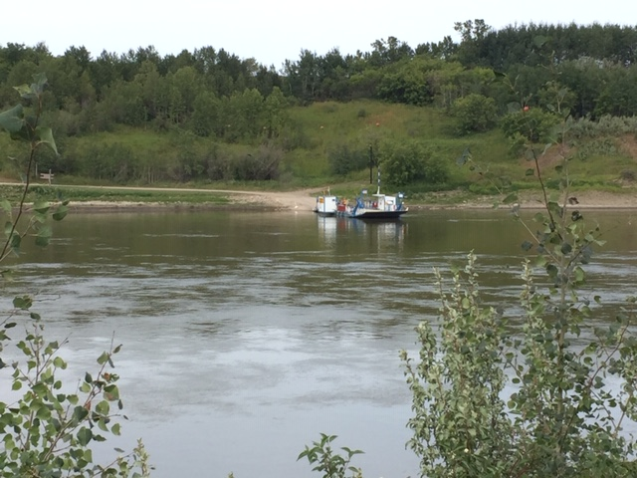

8. August 26, 2020 – Riverhurst Ferry, South Sask. River
Type: Cable, 18 cars possible, we crossed with two cars and two large semis. Crossing time = 24.5 minutes, across Lake Diefenbaker, which is 1.25 miles wide at this point. This summer the lake is the fullest it has been in years.
Daily crossings: average 200 vehicles, speed = 7 mph, has two operators – one in the tower, one running the ferry
Story #1: Today it’s running at half power while waiting for a part from Germany. It’s the largest cable ferry in the world. The cable seems to break at least once a year.
Story #2: A while back a semi lost his brakes, went on to the ferry, then over and into the water. The operator on duty needed to save the driver from drowning.
Events: Played nine holes of golf at the tricky Sage golf course, then visited the Lucky Lake Museum that included a guided tour by one of the area pioneers.
Brian – “After a delicious Korean coffee, we crossed the South Saskatchewan on a cable ferry, which is the largest in the world. The cable wraps 2.5 times around an 8 foot drum.”
John – “Our chattiest and friendliest operator told us the story about the semi that lost its brakes and the consequences that followed.”
LeeAnne – “In 1967 the Riverhurst Ferry made her first trip 1.25 miles across Lake Diefenbaker.”
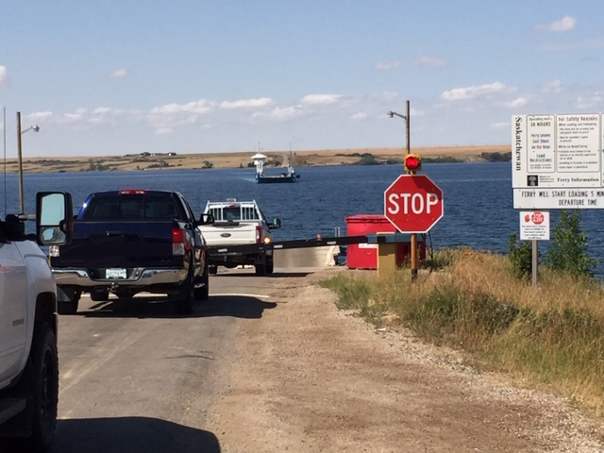
9. September 1, 2020 – Paynton Ferry, North Sask. River
Type: cable, Crossing time = 2.5 minutes
Today: there were white caps on the river, as it was very windy. Water splashed on to the car and ferry deck. It was so windy the ferry was having trouble going straight. The flag was sticking straight out.
Story: The valley has steep sides on both sides of the river. The approaches have been built up (probably this year) due to low water, making this crossing fairly short.
Side trips: After checking out the Husky Heavy Oil steam pressure plant at Vaun, we dined in Cochin. Then climbed the hill at the Cochin lighthouse on Jackfish Lake. We had hoped to play golf, but due to the nasty winds, decided to visit the Allen Sapp Gallery in North Battleford.
John – “Went across the narrowest crossing, with water splashing on to the car because it was so windy.”
Brian – “This crossing has the steepest ascent and had rebuilt roads on either side where the ferry crosses.”
LeeAnne – “Wind and white caps on the Panton Ferry crossing.”

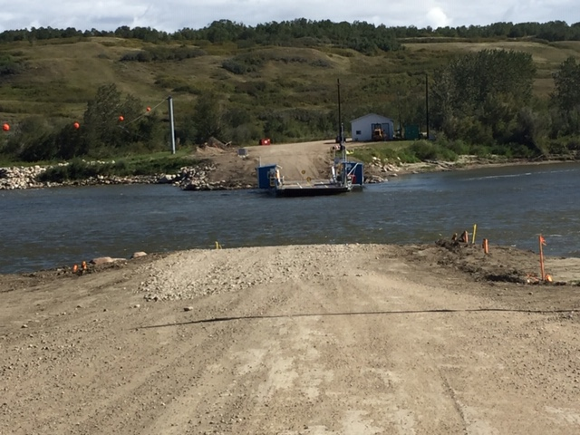
10. September 17, 2020 – Lancer Ferry, South Sask. River
Note: soft hills going to the ferry
Type: Cable. Crossing time = 2’13”
Daily crossings: today about 25-50. We had to wait about four minutes for the operator to show up – said he was on a late lunch break. He showed us a skull ring made by his buddy for his 67th birthday and a picture of a 4.5 foot sturgeon caught of the ferry. There have been two Prussian carp, an invasive species, caught recently.
Story #1: This year a person with a coyote in his boat crossed – the driver was jailed for stabbing
Story #2: Two weeks ago an operator was attacked by two persons during the crossing.
Brian – “After a 4 minute wait, a chatty ferryman appeared and filled us in on the numbers of crossings and reductions this year due to: Covid-19, no ball or hockey games, school not in, and parks closed.”
John – “ The ferryman was a danger man; attacked this summer by two individuals and he had no cell service to call for help.”
LeeAnne – “Two Prussian carp and one huge sturgeon have been caught off the Lancer ferry.”

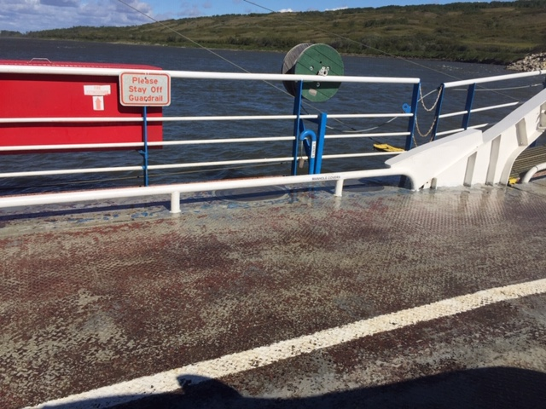
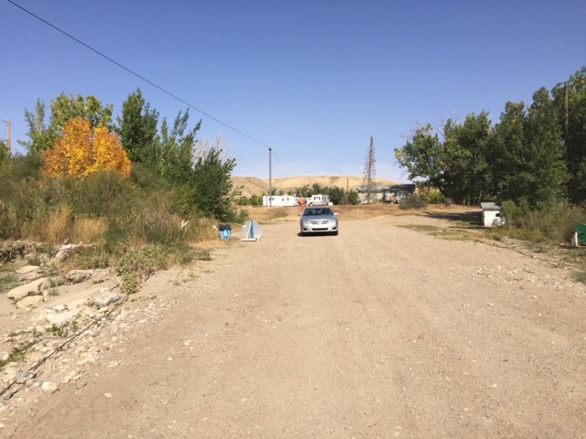
The road leading to the Lancer Ferry entrance

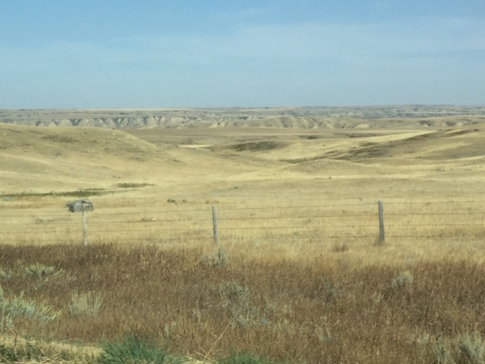
Plateaus and buttes near the Lemsford Ferry
11. September 17, 2020 – Lemsford Ferry, South Sask. River
We noted the many plateaus and buttes near the ferry.
Type: cable. Crossing time = 2’03”. One of the narrowest crossings. We timed it going both directions.
Daily crossings: very few. Our operator had trouble starting the ferry, and said she was just like all the others, working the crossings for something to do.
Events: After the crossing we played nine holes of golf at Leader, checked into Grandma Shirley’s Bnb, and ate at the local Chinese restaurant.
Brian – “Ferry crossing with one car or empty takes the same amount of time. The fishermen on the shore look disappointed.”
John – “Pony-tailed ferry woman took three tries to get the motor started for the crossing.”
LeeAnne – “Our third ferry woman has several years experience and thinks the ferries will be privatized in five years.”

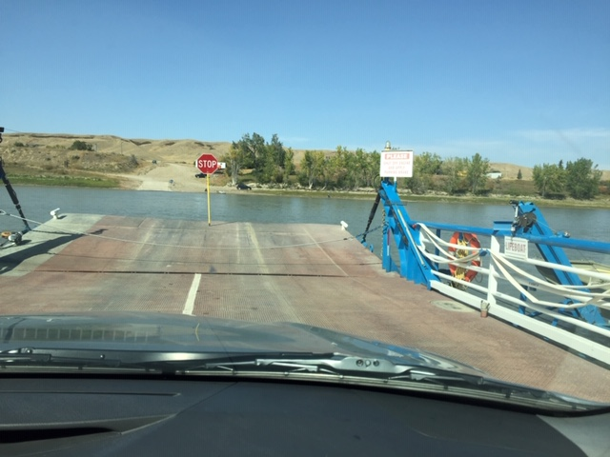
12. September 18, 2020 – Estuary Ferry – South Sask. River
Type: cable. Crossing time = 2’15”. Water speed is 140 cubic meters/second
Daily crossings: today, by 11:45, four vehicles crossed
Story: Our operator, with many years experience, had seen three floods in his time. In 2013 the water level was up to the yellow line on the shed on the bank.
Events: In the morning we noted the large wildlife sculptures scattered around Leader, later drove to Checkerboard Hill for the amazing and impressive view. We were able to see the forks of the Red Deer and South Sask. rivers, and noted two former train bridges (only the pillars are left now). We drove by the Estuary Hutterite colony, and after the ferry ride enjoyed a private tour of the Dean Francis art gallery located in a well-treed valley.
John – “The ferryman told us about the famer harvesting grain by two methods: heads off and the next strip is a regular cut.”
Brian – “Although this is the narrowest crossing, this ferry took basically the same amount of time as most of the others. During the high water level in 2013 the island in the middle of the river was obliterated.”
LeeAnne – “Estuary Ferry, final ferry ride in the spectacular South Sask. River valley.”

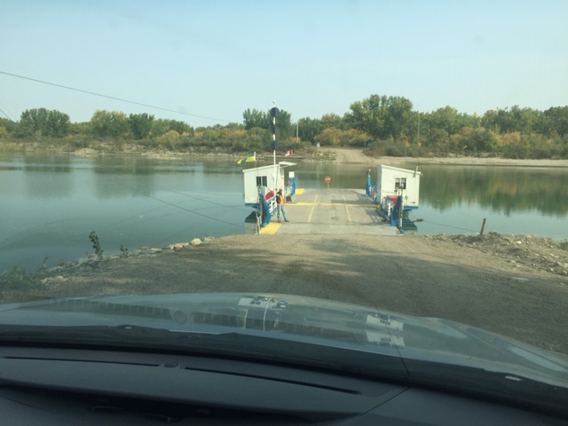
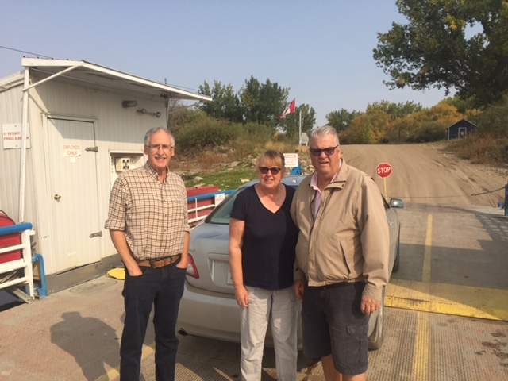
Last ride: 12 Saskatchewan ferries crossed, summer 2020

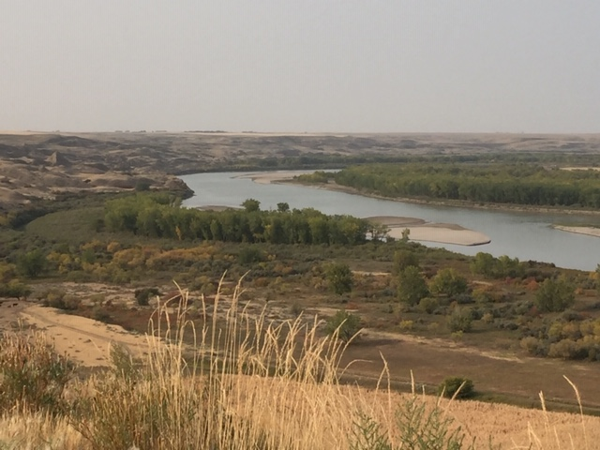
Forks of the Red Deer and Saskatchewan rivers
near Estuary, the furthest west ferry crossing.

